Front page main title
  - Subtitle (if any)
AUTHORS’S NAME

INSERT PICTURE

General instructions of inserting a picture:
- click the box
- click on Insert > Pictures > From file
- check that the style for the paragraph is “Kuvat”
- position the picture at the right height on the front page

ABSTRACT |  |  | DATE:
AUTHOR |  | MASTER’S OR OTHER DEGREE PROGRAMME
First name Last name (official name) |  | Degree programme
TITLE OF THE WRITTEN COMPONENT/THESIS |  | NUMBER OF PAGES + APPENDICES IN THE WRITTEN COMPONENt
Title of the thesis |  | E.g. 60 pages
TITLE OF THE ARTISTIC/ ARTISTIC AND PEDAGOGICAL WORK
Title of the artistic component, and if applicable, information about the performance (team, premiere, location).
Please also complete a separate description form (for the DVD cover).
The artistic work is produced by the Theatre Academy.
The artistic work is not produced by the Theatre Academy (copyright matters have been agreed upon).
There is no recording available for the artistic work.

Write the abstract text here. Use the whole space (min. roughly 250 words).

NB! You can tick the box of your choice by double clicking the box and then choosing Properties: Checked.

KEYWORDS
Enter keywords here. You can search for keywords here: http://finto.fi/ysa/fi/ (in Finnish) and
http://authorities.loc.gov/ (Library of Congress Authorities, in English)
You can also enter your own keywords that describe the content of your work.

TABLE OF CONTENTS
1. INTRODUCTION: STRUCTURE OF THE DOCUMENT template 5
1.1. Naming and saving the file 5
2. STRUCTURE OF THE THESIS 5
2.1. Abstract form 5
2.2. Table of contents 5
2.2.1. This is an example of a level 3 heading 5
2.3. Page numbers 5
2.4. Length of thesis 5
2.5. Inserting a picture 5
2.6. Printing 5
3. format your TEXT with STYLES 5
3.1. Importing text from another file 5
3.2. Subheadings 5
3.3. Section numbers 5

References
Appendices

INTRODUCTION: STRUCTURE OF THE DOCUMENT template
This is the Theatre Academy’s thesis template for MS Word versions 2008+. The purpose of this template is to help you with the structuring and layout of your thesis. The template includes a pre-designed table of contents and pre-designed styles. Following these instructions is important in order to avoid making changes to the pre- designed structure. The table of contents and the styles are interconnected.

The template includes general instructions for different versions of Word. In your version of Word, the names of styles and the paths to functionalities may differ from what is stated in the instructions. You may also find help from Word’s Help tab.

Naming and saving the file
Start writing your thesis by saving this file in a folder of your choice. The name of your thesis file should adhere to the following model: Firstname_Lastname_20XX.doc (or docx). You should also store the original template so that you can check certain settings or instructions later.

STRUCTURE OF THE THESIS
The structure and styles of the thesis have been set in this template. The template is divided into the initial pages and the actual text content. The structure of the initial pages is as follows: cover page (p. 1), abstract (p. 2), table of contents (p. 3). The actual text content starts with the introduction (p. 4). Do not make changes to the structure so as not to lose the headers of the initial pages or, for example, mix up the page numbers. If this has already happened, the easiest option may be to start over with the blank thesis template and copy the texts you have already written. You can change the year on the cover page by editing the header section.

Abstract form
You can find the abstract form on the initial pages (p. 2) of the thesis. The abstract page serves as the student’s maturity test for the Master’s Degree. Replace the instructions with your abstract. You might find the General Finnish ontology (YSO) useful when choosing keywords: http://finto.fi/yso/fi/. In addition, you can use your own keywords to describe your thesis.

Table of contents
NOTE! Do not edit the table of contents manually under any circumstances. Edit the table of contents only by using the ”Päivitä kenttä”/”Update Field” functionality.

You can update the table of contents by moving the pointer on it, clicking the right-hand button and selecting ”Päivitä kenttä”/ ”Update Field” > ”Päivitä koko luettelo”/ ”Update entire table”.

The table of contents has been pre-created on the initial pages of the thesis. Do not forget to update it as you progress and before you print the thesis. If the table of contents disappears (e.g. it is accidentally removed), you can re-create it by selecting Insert > Index and lists... > Table of contents >> From template (levels 1 or 3, show page numbers) > OK

NOTE: If you are unsure about the process, save the file before making any changes. This enables returning to the starting point if something goes wrong.

This is an example of a level 3 heading

Page numbers
The template has pre-determined page number settings. NOTE! Do not change the page number settings.

Length of thesis
The length of the thesis (e.g. 60 pages) is calculated by starting from the first actual text page, that is, page 4.

Inserting a picture
In order to insert a picture, select ”Kuvat” as the style of the paragraph. Then, select Insert > Pictures > From file...

Always mention the name of the person who has taken the picture and make sure you know who owns the copyright. Any pictures you use must relate to the subject matter of the thesis. Further information about using pictures in the thesis is available at https://libguides.aalto.fi/imagoa.

If you use numerous pictures in your thesis, you can compile the pictures’ details at the end of the thesis in the picture references section.

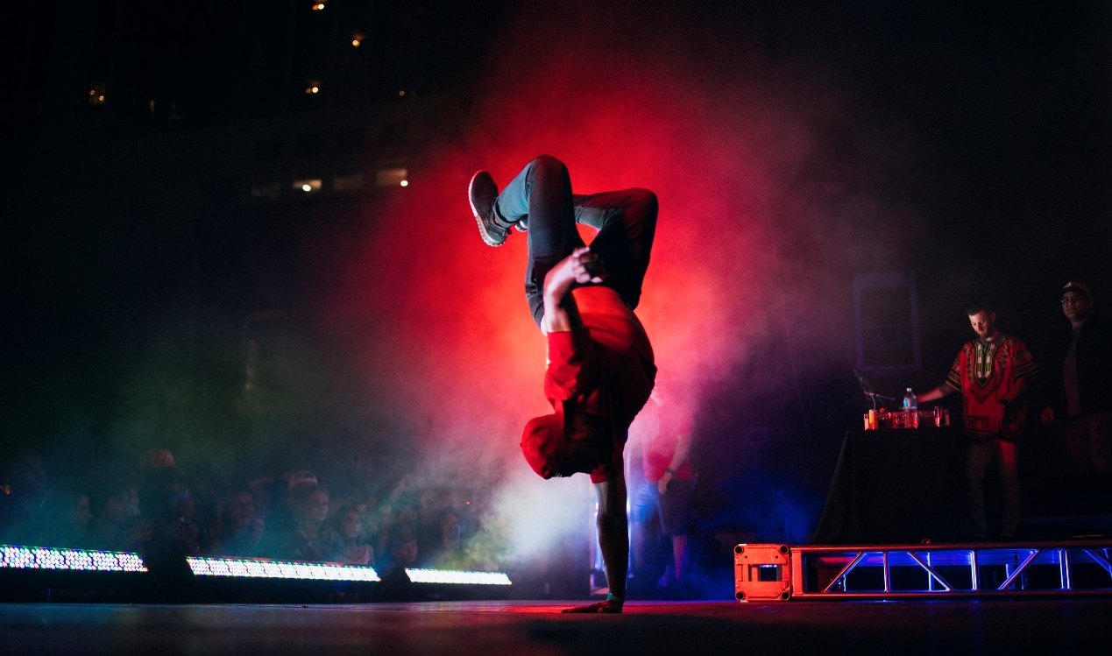
The caption is placed under the picture. (E.g. Name of the performance. Director/choreographer. Photograph: First name Last name.)

Printing
When printing the thesis, ensure that the setting for printing on both sides is selected. The settings for printing on both sides are printer-specific. Thus, this file will not be printed on both sides automatically.

format your TEXT with STYLES
The font of the thesis’ body text is Times New Roman, the font size is 12 pt, and the line spacing is 1.5. The font of headings is Times New Roman, the font size is 18 pt, and the line spacing is 24 pt. The font of subheadings is Arial, and the font size is 14 pt. The styles of the thesis, including font, font size, line spacing etc., have been created using Word’s styles options. Do not change them.

Always start new chapters on a new page. A page break is automatically inserted between chapters when you select ”Luvun otsikko” (Eng. Chapter heading, Heading 1 in Styles) as the style of the chapter heading. Please note that the ”Sisällysluettelon otsikko” (Heading – Table of contents) style should not be used in the actual text as it will not be updated in the table of contents.

The actual text is written using the style Normal. The text is aligned on the left. Do not indent the first line of a text paragraph. Paragraphs are separated from each other by a blank space.

You can find the styles in the Home tab (Figure 1). If you wish to create a new subheading, for example, click on the text and select Heading 2 from the Styles group (Figure 1). If you do not see the style you require, click on the small arrow on the lower right-hand corner of the Style menu..

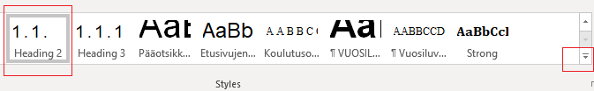FIGURE 1. The Styles group can be found in the Home tab of Word’s top bar.

The thesis supervisor will provide instructions regarding referencing practices. Further information on references is available in the Structure and Annotation Guide.

Importing text from another file
If you import text using the copy–paste functionality, insert the text without formatting (Edit > Paste Special... > Paste Unformatted Text). In that case, the text is inserted as a single block which you can edit by selecting the appropriate styles.

If the text you are trying to import does not adapt to the template’s style, and the font, for example, does not change, try the following:
1. Select the text.
2. In the Styles menu, select “Clear Formatting”.

Subheadings
A chapter may include subheadings. Use Heading 2 and Heading 3 styles for them. Additional line breaks are not required above subheadings. The required empty space comes with the style.

Section numbers
Use the numbered styles for headings: ”Heading 1”, ”Heading 2” or ”Heading 3”.

